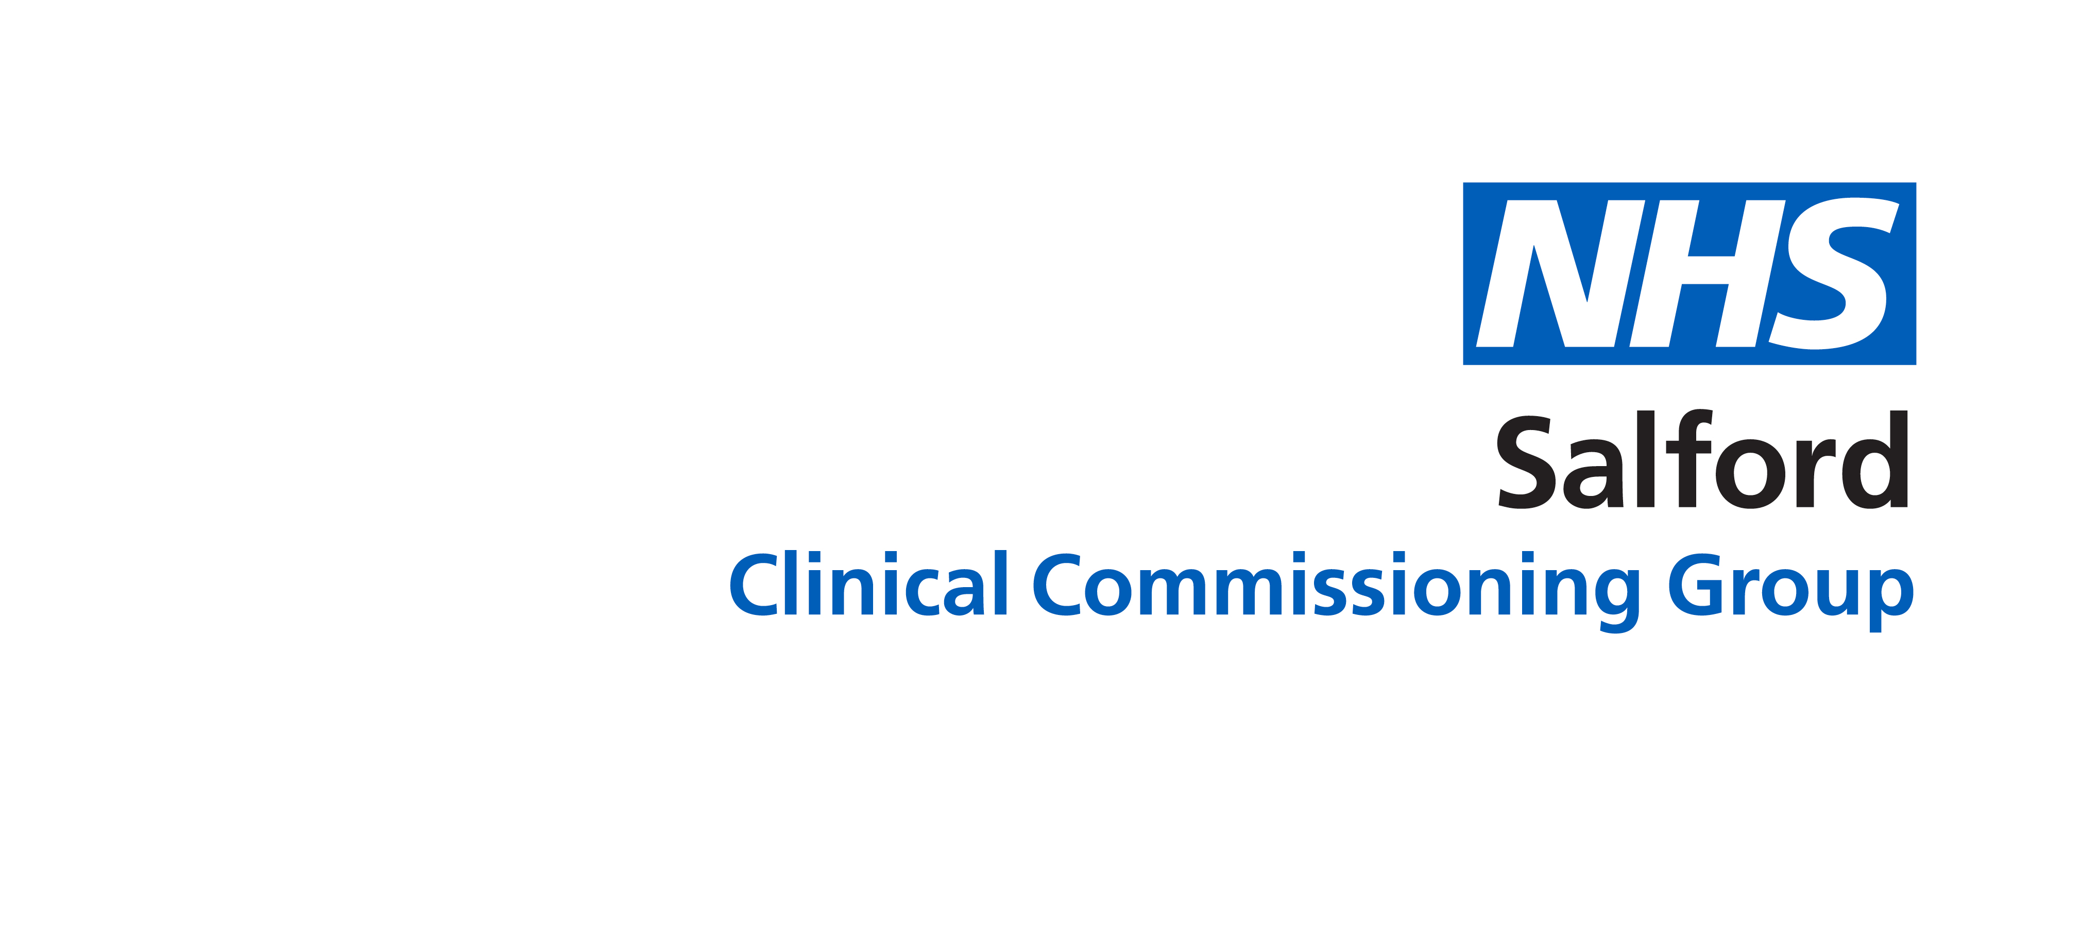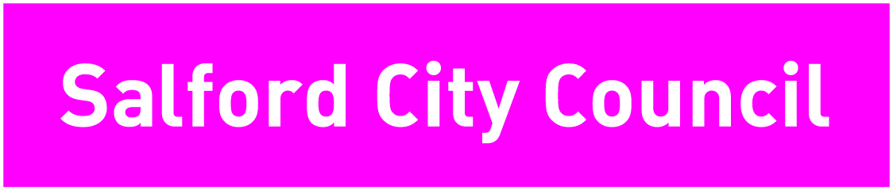

The Intergenerational Toolkit for Salford

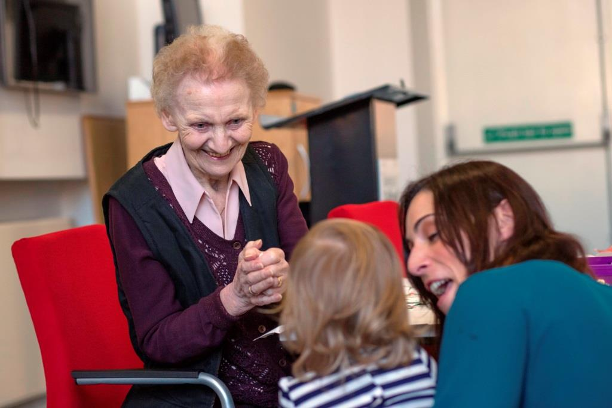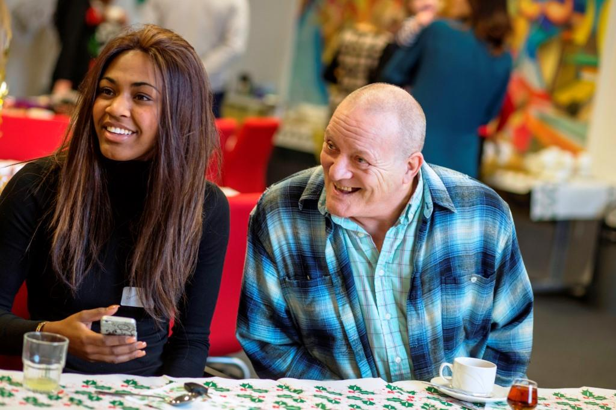

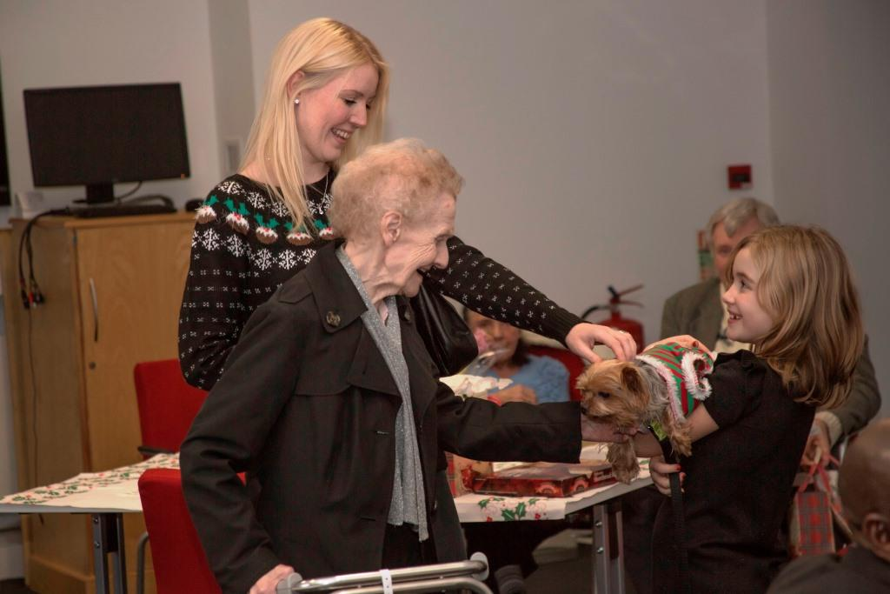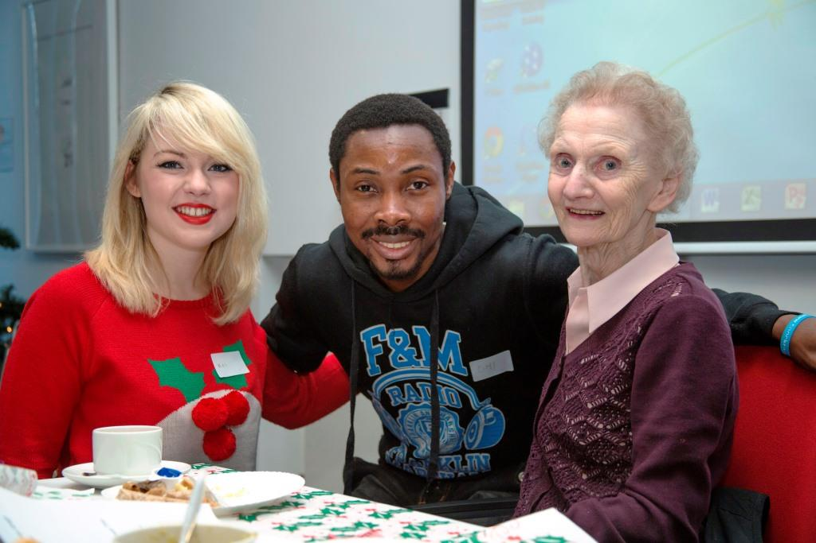

Introduction 2
Who is this toolkit for? 2
The benefits 3
Planning process 5
Evaluating your project 9
Recruitment of volunteers 10
Preparing to work with younger and older people 11
Overcoming barriers between generations 13
Your first meeting with both age groups 16
Additional resources 18
Acknowledgements 18

Introduction

An intergenerational approach brings generations together in a purposeful and mutually beneficial way, involving them in activities which promote greater understanding and respect between generations, challenging stereotypes and addressing age discrimination.

Older people and younger people have valuable contributions to make to society. Generations have different types of knowledge and experience which should complement each other. The flexibility of an intergenerational approach means that there can be a diversity of initiatives delivered under the banner of intergenerational activity. Projects can be cultural, sport based, community led, short-term one off events or long-term projects. The key outcomes of projects are positive learning experiences for individuals from both generations.

Working together in Salford

This toolkit explains what intergenerational practice (IP) is and why you might want to make use of it. It brings together tools and advice and will help you set up, deliver and evaluate a successful intergenerational project or programme of your own.

Who is this toolkit for?

It is primarily aimed at people whose work is primarily to engage with the community.

You will need to have:
- Experience or training in project planning and strategic planning
- The ability to communicate clearly to a range of audiences in different ways.
- The ability to give a good presentation
- The ability to facilitate meetings with colleagues and project participants.
- An open minded, adaptable approach

The benefits

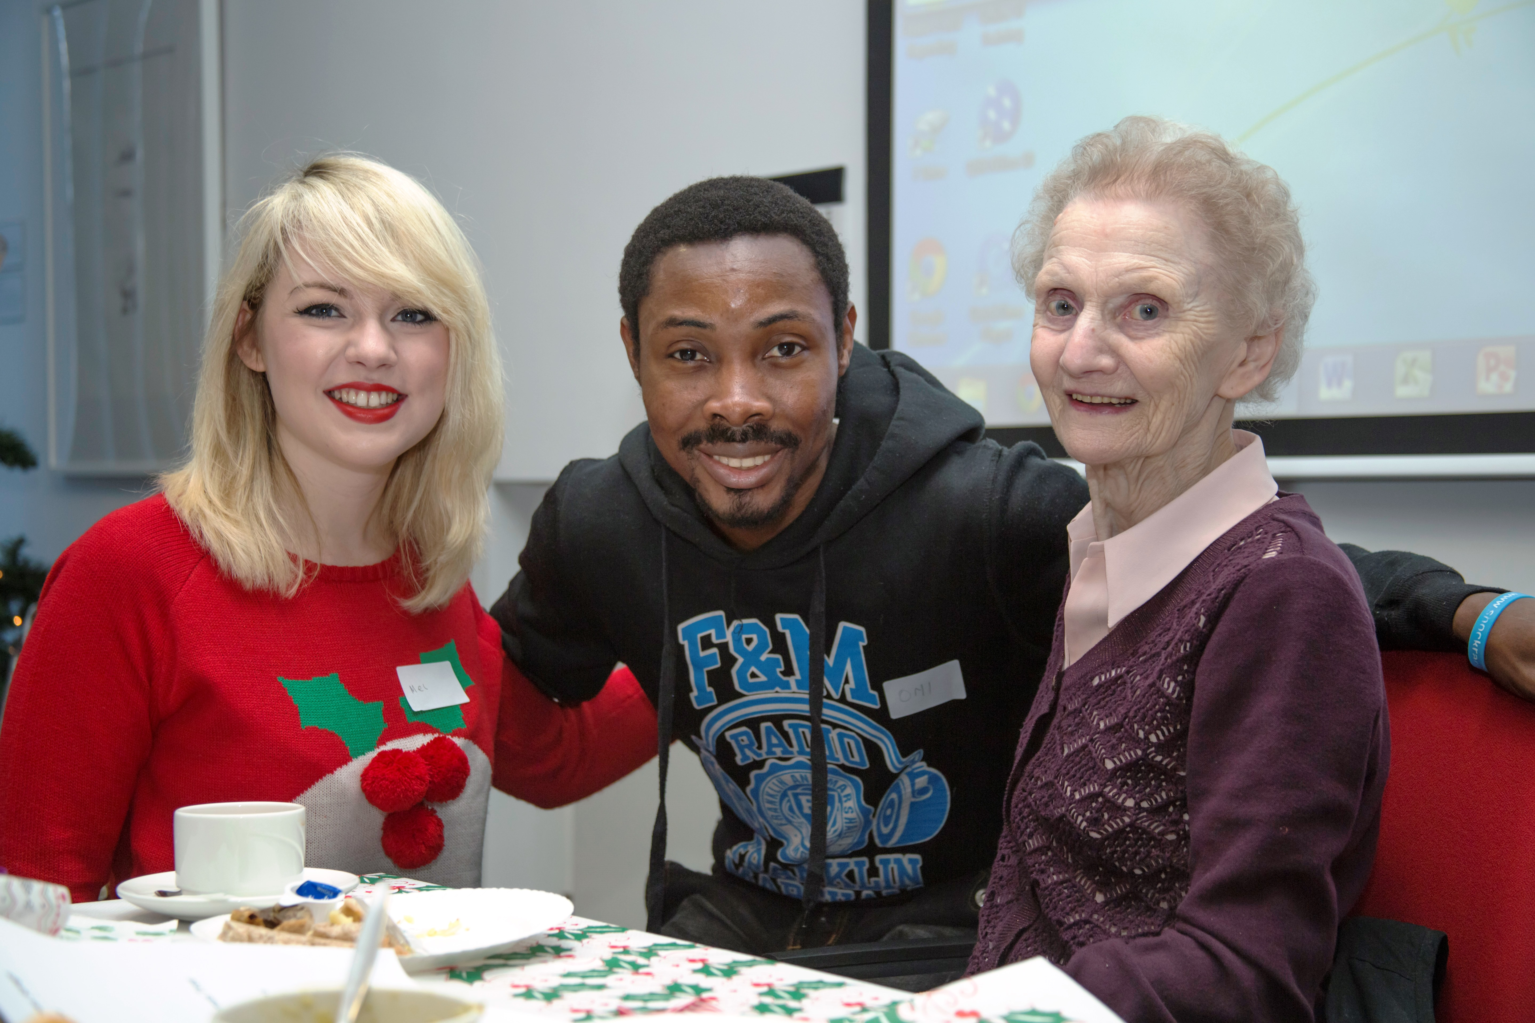Intergenerational practice is inclusive, using the positive resources that different generations have to offer each other and those around them.

It has the potential to reduce tension and misunderstanding between groups and can offer solutions to many of the social issues that concern communities. These outcomes can often directly complement current government initiatives surrounding inclusion and sustainable communities.

Building active communities
Bringing generations together in a safe environment gives both generations the capacity to understand and engage with each other; developing stronger more sustainable communities.

Promoting citizenship
Appreciation and understanding of other individuals in communities deepens a commitment to active citizenship, alongside enabling often-polarised age groups to have a united voice.

Intergenerational activities complement National Curriculum citizenship objectives in relation to knowledge, understanding and skills of enquiry.

Regenerating neighbourhoods
Working collaboratively with generations enables stronger consultancy and community engagement. It can provide the drive to regenerate neighbourhoods whilst also ensuring sustainability.

Addressing social exclusion
A large proportion of individuals engaged in intergenerational work report new-found feelings of belonging and being part of a community. An intergenerational approach can be used to re-engage those who often feel isolated.

Health promotion
A wide variety of intergenerational activities support healthy initiatives; for example, regular physical activity and healthy eating. Individuals also note benefits from being mentally, physically and sometimes emotionally engaged.

DigitaI inclusion
Delivering intergenerational digital inclusion initiatives brings different generations together in an interactive teaching and learning environment, helping bridge the digital divide.

Intergenerational projects are a great way to volunteer in the community. Older participants in intergenerational programmes have said they have felt:

- An improvement in self-esteem
- A feeling of self-worth and recognition
- A greater awareness brought about by new learning opportunities
- A more positive mental attitude
- Increased confidence to make new friends and contacts in their community

Intergenerational activity improves overall quality of life for the individual, both old and young alike.
These benefits show how intergenerational practice contributes to the aims of Salford’s Health & Wellbeing Strategy.

Intergenerational practice is based on the principle that if older and younger people work together in an equal power relationship, it can benefit themselves and others in those age groups and the wider local community.

By giving people a time, place and structure to do this, it helps different generations share their past, present and hopes for the future.

Once you have a good understanding of intergenerational practice, it’s time to get a good understanding of your own project.

For an intergenerational project or programme to succeed, it needs to have a clear set of aims and objectives, and a clear planning process.

Planning process

Pre project checklist

Before setting up an intergenerational activity, we recommend checking that your organisation is in a position to support such an initiative. Ensure you consult with colleagues within your organisation who are responsible for volunteering, insurance and human resources.

Below is a quick check list of things to consider:

- Does your organisation have sufficient insurance to cover intergenerational work?
- Do you have funding and/or resources to deliver the project?
- Do you have a ‘Safeguarding Children’ policy?
- Do you know how to screen volunteers (if necessary)?
- Have you amended/created new volunteering policies/agreements?
- Have you thought through the aims and objectives of your project?
- Have you looked into Health and Safety needs?
- Have you carried out risk assessments for the activity, including the venues to be used?

Risk Assessment

Risk Assessment is a very important part of any project. However, people tend to run the other way as soon as they hear the term. Risk Assessment is nothing to be afraid of. It is just a way for you to identify hazards, that is, anything that could cause harm or a problem (namely, what could go wrong) and then think about the risk, that is, the possibility of the hazard causing harm or the problem occurring (what is the likelihood it will go wrong).

A hazard can be classified as slight, serious or major and a risk can be classified as high medium or low. Make sure that this is clear and that everyone is in agreement and understands what this means. http://www.hse.gov.uk/risk/assessment.htm

Below are the key questions you need to ask yourself about your project in the early stages of planning. Once you’ve considered these, you will be ready to fill in the project planning table.

Intergenerational Planning Table
WHO?  Who are you working with? | - Which groups of younger and older people will be involved in the project?  - Who is working with them at the moment?  - Which other organisations will help you deliver it?  - What could be the barriers?
WHAT?  Has your project been done before? | - What has been done before in Salford or anywhere else similar to what you are aiming to do? Research previous intergenerational projects.  - What types of community engagement tools you are using within your project?
WHEN? | - What is the timescale of your initiative?  Will it be a one -off or a first step to services changing how they operate with younger and older people?  - Set out when you will start and finish and important dates for the milestones and outputs of the project
WHERE? | - Remember that what works in one area might not work in another. Keep an open mind and always be ready to change your approach if need be  - Consider which neighbourhoods you will be working in and why  - Look at what location or facility you will base your activities in, is it safe, accessible, comfortable and warm?

WHY?  What national and local strategies does this work link in with? | - Outcomes in the community e.g. "what difference does it make?"  - Greater co-production between age groups  - Improvement in health and wellbeing  - Resilient communities
 | - Outputs e.g. "what we do and who we reach” The number of volunteers engaged in the project
 | - Added value “the extra from the project” New skills, knowledge and understanding Wider community awareness
Costs | - How is the project being funded?  - Always adhere to the set guidelines outlined  - Always factor in volunteer expenses including transport where possible
Evaluation  You must be able to demonstrate what you plan to do will deliver value for money and have a positive impact on Salford residents. | - A clear process of evaluation, based on the purpose of the project, at the start, middle and end.  - Results – especially in terms of the work’s impact and what it has changed.  - Methods of collating evidence: evaluation forms/photos/ videos/workshop
- Did the project meet the aims and objectives What worked well/not so well/what could be done better?
- A clear rationale for developing it further if future work is planned.

Evaluating your project

When developing an intergenerational activity, remember to establish systems to monitor and evaluate your project against your original aims and objectives. Monitoring and evaluation should not just be a paper exercise. It should tell you where you are going wrong (as well as what’s working well), and guide you on the steps you can take to improve things.

Monitoring is about systematically collecting information that will help you answer questions about your project. You can use this information to report on your project and help you evaluate.

Evaluation is about using monitoring and other information you collect to make judgments about your project. It is also about using the information to make changes and improvements.
Monitoring and evaluating your project will help you assess how well you are doing in order to help you do it better. The information gained can be used to develop your intergenerational activities in the future.

Before starting your intergenerational activity, review your aims and objectives and think about what monitoring and evaluation systems you would like to put in place. This will help you establish whether your project has delivered on its expected outcomes.

Once you are clear what your project is aiming to achieve, think through the questions you will need to ask and the information you will need to gather to determine whether the project has achieved what it set out to do.

Establishing any monitoring and evaluating systems at the start of a project can eliminate stress and concern over collating information at the end of the project. Funders will often ask for end of year reports and future funders/supporters may be interested in seeing the outcomes of previous work.
Systems for information collecting can include questionnaires and focus groups, as well as other monitoring systems that may exist in the partner organisations you work with.

Recruitment of volunteers

Be clear about the aims and objectives of your project when recruiting individuals in order to manage expectations and ensure commitment. Remember to highlight the benefits of volunteering to the individual.

Attracting older participants or volunteers:

- Try targeted recruitment through community venues and buildings, sheltered housing, religious centres, libraries, leisure centres and local groups and lunch clubs
- Use flyers, talks, posters, editorial pieces, free or paid advertisements, broadcasts.
- Approach local newspapers, community group newsletters
- Forge links with other community and voluntary organisations, e.g. ethnic minority groups
- Use Council for Voluntary Services (CVS)

Contact other professionals in health, education or social services and local neighbourhood teams who work with older people.

Attracting younger participants or volunteers:

- First identify the appropriate profile or age group for your activity (college students, sixth form, Years 7-11, Years 1-6, nursery, pre-school)
- Build partnerships with key staff at local colleges, schools, nurseries, youth clubs, ‘guide or scout’ type organisations, community groups
- Contact other professionals in health, education or social services and local neighbourhood teams who work with young people.

Don’t forget to utilise support from all social networks Face book, Twitter etc…

Preparing to work with younger and older people

These are two age groups with different identities, abilities and levels of experience. Your challenge is to balance their contrasting approaches, while also letting them shape these as the work goes on.

This isn’t an easy task but if you follow the advice below, most difficulties should be avoided.

- Be clear about your role

Are you the facilitator, Project Manager or Programme Manager? Or all of these at different stages? Have you a job description?

- Be clear about the role of participants

Adults become used to having power over young people and the idea of devolving some of this power may seem strange. How will you prepare them for this?

- Know what the project is based on

Was the project your idea, or an idea that originated from younger and/or older people? Or has it come from elsewhere?

Get a good sense of the reasons behind the project. For example, if you are basing a project around a perceived problem with young people in a park, find out what these perceptions are based on, and what the expectations are of those holding these beliefs.

- Plan the pace of the work

How will you balance the needs of younger people with the needs of older people? And how will you help your participants develop this balance themselves?

- Make communication accessible

Consider how you will communicate with older and younger people. Avoid confusing jargon and acronyms and ensure that the text and design of written communication is accessible. Don’t presume that everyone has access to the internet or email. Also, ensure that your communication is interesting and exciting. Why would anyone give their time to be involved in something boring if they don’t have to?

- Make sure you’ve done age-related checks

If participants are under 18 you will need parental permission to work with them and all people involved in the project will need checks. The field of DBS checks is often changing and requirements can vary (for example schools may have different policies). https://www.gov.uk/disclosure-barring-service-check/overview

- Be prepared for ageist attitudes

Older and younger people might hold negative perceptions of each other. If this is the case, how will you deal with this? Also, be aware that your participants may have had to deal with negative attitudes towards themselves in the past – these experiences need to be factored into your approach.

Overcoming barriers between generations

There are various ways of addressing the gaps which may exist between people of different generations. This section looks at how you can bridge these by bringing the two age groups together through a gradual process with careful planning. It then suggests a number of discussion points that will help people explore ageist assumptions.

Meeting the two age groups separately

Take the opportunity to meet the different age groups before bringing them together for the main activity. It can often be nerve wracking meeting new people, especially new people who you feel you may have little in common with. Working with the groups separately beforehand enables individuals to discuss their apprehensions and talk about being part of an intergenerational project.

Discuss the aims and objectives of the project/ programme and why you have all come together so the group is aware of their role within the project.

Rules

After individuals have introduced themselves is the perfect time to establish ground rules for the activity ahead. Ground rules or ‘codes of conduct’ (you can ask the group what they want to call them) provide guidelines that the group agree to follow throughout the activity. All rules should be agreed by all participants involved. Ask the group to sign up to the rules, either physically by signing the paper they are written on, or raising their hands in support. Ideally individuals will police themselves when it comes to behaviour, although if any problems should arise during an activity, the ground rules provide a good point of reference for appropriate conduct.

In general, ground rules should include:

- A focus on equality, diversity and respect
- Basic codes of politeness and good behavior
- Anti-bullying messages
- Health and safety

More issues to discuss together:

- Appropriate boundaries
- Language and physical contact
- Confidential information
- Safeguarding
- Recording the work (for example use of photographs and social media);

At this stage ask each group to develop a top 10 tips for working with the other group e.g. positives to think about.

10 top tips when working with older people
(Compiled by the Salford CCG/Salford Royal Health Ambassadors)
- It is important that everyone gets to know each other, alternate the seating arrangements to encourage dialogue if people feel comfortable.
- It is important that everyone feels at ease, so start each session with an icebreaker exercise.
- It is important to listen and not dismiss anyone’s point of view.
- Show respect. No idea or suggestion is a silly one.
- It is important that we consider the language weuse, let’s try not to use slang and acronyms
- It would be great that a member from each group chaired alternate meetings, so both partners feel equal.
- It’s a great opportunity to challenge stereotypes which group members may have about each age group. This theme should form part of the event.
- It is great to try new things, let’s be adventurous and vary the refreshments at each meeting.
- Need to make sure everyone has enjoyed the activity/meeting by asking how the next one can be improved.
- Finish off with something funny to make you want to go to the next activity/meeting.

10 top tips when working with young people
(Compiled by Salford Forum For Older People)
- We agree to respect each other when we meet up and work together, and draw up an agreement that both groups are happy with.
- We make sure we turn our phones off during meeting so we can concentrate on what we are discussing and not be distracted.
- We agree to listen to each other, so we do not have to keep repeating everything.
- Check if any assistance and support is needed for anyone to get to the meeting or when at the meeting.
- It is nice to have the right meeting environment. Making sure it is safe and accessible for those who may have some form of disability, and It is comfortable, warm and we keep it clean.
- We need to work with an established small group who are used to meeting up, small is intimate so it is easier to get to know each other. This can be opened up at a later date to more people.
- We would like all members of the group to be committed and agree to take outlined actions forward, and for people have a responsibility to do this when they say they will do it.
- Having the right representation – Because the main aim of this group is to promote young and old working together in college, we need to look at the barriers they face in accessing activities and lessons.
- Because people have various disabilities and need various support to access the colleges we need to have equality and diversity awareness.
- We need to identify level of skills of both groups, to look at if we need any combined training.

Your first meeting with both age groups

When the group meets for the first time, try to create an environment of security where friendship and cooperation can start to develop. The venue should be local and provide a safe environment for both groups. You need to ensure you have enough money to support people from both age groups who may need transport to get to and from the meeting. They may even need support from a carer to attend.

Prior preparation - such as name tags / labels and designated seats - can also encourage people to feel more at ease.

Having met separately before the day, participants should be aware of the aims of the activity and their role within it. It is worthwhile reiterating the aims and objectives of the programme to create a focus of a shared common goal.

Introductions can vary depending on your group dynamic. For mentoring programmes, informal ‘getting to know you’ chats between the two generations may be appropriate. Name game activities may be best if working in a group to help break down barriers and combat shyness.

Do not think that by merely coming into contact with one another, young and old will immediately connect and understand each other and that bonding and relationships between the generations will occur magically and automatically, without any need for outside assistance.

It takes planning and concentrated effort to successfully prepare young and old to be comfortable with one another.

Know who is coming and what the meeting space is like
It is always helpful to visit the space where you will first meet and/or carry out your project or programme. Know the safety issues, where the toilets are, planned fire drills, availability of refreshments, the size of the space, and accessibility issues.

Where possible, use venues that are neutral to both age groups or discuss the venue choice with participants before activities start.

Be clear about the purpose of the first meeting
Have clarity in your own mind and communicate this to participants. If possible, send them information or speak to them about the meeting’s purpose beforehand.

Be clear about the purpose of the project
Talk to participants about why you are doing the project, the scope for it to change, how it will be carried out, and the timescales.

Have back-up plans
What will you do if something doesn’t go to plan? As far as we know you can’t see into the future, but try to be prepared to deal with tricky or surprising questions or responses.

Be aware of what has happened in the past in that neighbourhood
You could duplicate things that didn’t work, or ask questions which people have already answered (for example if you are running a consultation) which will just serve to annoy people. Consider what you could build on, such as existing partnerships, networks and learning.

Paperwork
Partnership agreements and contracts, personal checks, consent forms for photographs/trips, and registers. Confidential database set up and protocols for use established.

Location
Transport requirements identified. Is the area safe and well lit and accessible by a range of travel options?

Venue checklist
- Risk assessment completed
- Disability access
- Equipment available and first aid kit
- Room size and space for your use/furniture
- Hearing loops
- Venue contact for any problems

Staffing checklist
- First aider available
- Adequately trained/checked staff
- Contact information list

Volunteers checklist
- Contact information
- Support available if required
- DBS checked, if required
- Volunteer policy which includes arrangements for support

To make your intergenerational project successful, always be clear on what you are doing, why you are doing it, who you are doing it with, where you are doing it, when you are doing it, and how you are doing it.

Toolkit produced by:
Caroline Allport, Engagement and Development Officer
Salford City Council / NHS Salford Clinical Commissioning Group
caroline.allport@nhs.net / 0161 212 4953

Additional resources
Beth Johnson Foundation – Centre for Intergenerational Practice www.centreforip.org.uk

Lots of useful tools and publications on age concerns intergenerational approach. Joseph Rowntree Foundation www.jrf.org.uk

Community engagement planning www.communityplanningtoolkit.org

Acknowledgements

- Developing an Intergenerational Programme in Your Early Childcare and Education Centre’ in A Guidebook for Early Childhood Practitioners
- Patrick Hanfling from the Valuing Older People Team in Manchester City Council

